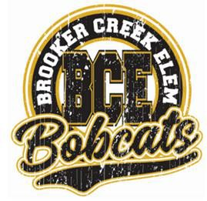BROOKER CREEK ELEMENTARY SCHOOL

Kindergarten

2024 - 2025 KG Supply List

|  |
| --- |
| **The following items are needed:** |
| ⇨ 1 Full size Backpack – no wheels  ⇨ 1 Pair of headphones- no earbuds please (Labeled with your child’s name)  ⇨ 1 black cover composition notebook (wide ruled)  ⇨ 1 red cover composition notebook (wide ruled)  ⇨ 1 basic plastic pencil box (solid color)- approximately 5x7 (please label with name)  ⇨ 1 box of 24 *Crayola brand crayons (not florescent)  ⇨ 1 box of *Crayola brand **thin** markers  ⇨ 1 box of *Crayola brand **classic/bold** markers  ⇨ 1 black Sharpie  ⇨ 1 pair of \***Fiskars** scissors (metal point – be sure to get the child size)  ⇨ 1 package of #2 Ticonderoga pencils (pre- sharpened)  ⇨ 1 box of colored pencils  ⇨ 24 glue sticks  ⇨ 1 box gallon storage bags – unpleated (girls)  ⇨ 1 box quart storage bags - unpleated (boy)  ⇨ Cardstock – White  ⇨ Cardstock- Color (girls)  ⇨ Cardstock - Neon (boys)  ⇨ 1 large box of tissues  ⇨ 1 container of baby wipes  ⇨ 1 container of Wet/Clorox wipes  ⇨ 1 bottle of antibacterial pump soap  ⇨ 1 bottle of hand sanitizer  ⇨ 1 white, 2-inch, 3 ring, clear view binder with pockets  ⇨ 1- white, 1 ½ inch, 3-ring, clear view binder with pockets  ⇨ 1 - 4ct black expo markers  ⇨ 100 clear view sheet protectors  ⇨ Yellow Highlighter  ⇨ 1 package of 3 white t-shirts (one size larger) Please label bag- not individual shirts   * Note: We have found these brands to have the truest colors and be most effective   with little ones. Teachers may request additional supplies based on specific classroom needs. |